The Business Credit Management Association – Wisconsin  15755 West Rogers Drive, Suite 100  PO Box 510157  New Berlin, WI 53151-0157  Voice 888.546.2880  www.wcacredit.org | The Professional Credit  Management Association  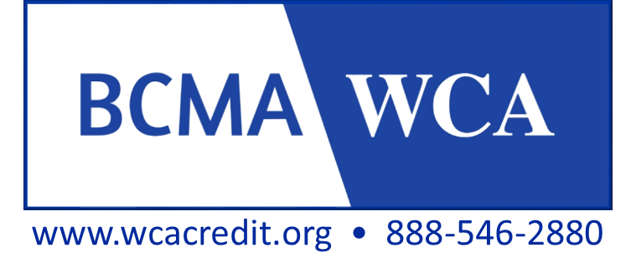
2022 WCA EDUCATIONAL  SCHOLARSHIP APPLICATION  Requirements for Scholarship Approval:  - Company must be a member of WCA in good standing.  - Application & additional pages must be completed online & submitted to WCA via Email. No faxed or mailed copies accepted.  - Accompanying documents must include your name.  - Application must be submitted 3 weeks prior to the date of the event if applying for the Conference or a Technical Program.  - Scholarship must be used within one year from date of issue. | Your WCA Scholarship Committee Members  Diane Zancanaro CCP CPC Chair  Chaz Heckman CPC  Wayne Crosby, BCMA WI  Nicole Thompson, BCMA WI
Name | Check All That Apply:  CCP  CPC  CBA  CBF  CCE  OTHER Specify

Title

Years in Current Position #

Company Name

Company Address
City State Zip
Phone
Fax
Email
Your Supervisor or Manager’s Name, Title & Email Address

Describe your current professional duties:

College Degree: Yes No If Yes, list your Major:
Master’s Degree: Yes No If Yes, list your Major:
List WCA Sponsored courses, seminars, workshops & conferences you have attended in the past 3 years: | Dates:  (Month & Year)
If more space is required, please attach separate piece of paper including your name and page.
Have you ever received a WCA Scholarship? Yes No If Yes, please let us know how much, for what, and when you received it:

Would your company pay for the fees or a portion of the fees for the course, conference or program(s) you are applying for today: Yes No . Briefly describe:

ADDITIONAL INFORMATION
Check here, additional information you have attached to this application:
Résumé (not required)
Additions to courses, seminars & workshops attended

Page Two WCA Educational Scholarship Application

Your Name

SCHOLARSHIP CATEGORIES
All scholarship applicants have the option of applying for up to one scholarship per category if funds are available. If approved for a scholarship, the funds will be paid from the fund upon completion of the course or attendance at the event for which the scholarship was awarded. Evidence of completion may be the Student Record Form you receive at the event or your Course Certificate.
PLEASE CHECK (X) WHICH SCHOLARSHIP (S) YOU ARE APPLYING FOR FROM CATEGORIES BELOW:

CATEGORY I: CREDIT PROFESSIONAL’S CONFERENCE
THE DEADLINE TO APPLY FOR A SCHOLARHIP IN THIS CATEGORY IS 3 WEEKS PRIOR TO THE EVENT. You will be notified about your application for this scholarship no later than 10 days prior to the Conference.
Amount of reimbursement you are applying for:
ONE-day Conference registration ($150 maximum award per person to be applied toward fees)
TWO-day Conference registration ($250 maximum award per person to be applied toward fees)
Are you a first-time Conference Attendee? Yes No

CATEGORY II: WCA TECHNICAL PROGRAM (Full or Half Day)
THE DEADLINE TO APPLY FOR A SCHOLARHIP IN THIS CATEGORY THREE WEEKS PRIOR TO THE DATE OF THE PROGRAM. Up to $100 per person, per program scholarships are awarded in this category.
List the name of the program:

CATEGORY III: CREDENTIALING PROGRAM FEES – ACCREDITATION THROUGH THE BUSINESS CREDIT MANAGEMENT ASSOCIATION FOR THE CERTIFIED CREDIT PROFESSIONAL (CCP) & THE CERTIFIED PROFESSIONAL COLLECTOR (CPC)
There is no deadline to apply for reimbursement of fees in this category. You will be notified about your application no later than one month from the date you apply for this award. Check (X) which of the following fees you wish to be considered for reimbursement. You may apply for only one in this category. Reimbursement for Scholarship Award in either category is made to original payee upon notification of your records evaluation from the Credentialing Standards Board (CSB).
Award for reimbursement of Application for Council Record up to $125 per person or
Award for reimbursement of Filing Fee For Accreditation Certificate(s) up to $175 per person

CATEGORY IV: COMPREHENSIVE CREDIT PROFESSIONAL’S TRAINING SERIES
I am applying for a $150.00 scholarship to use towards fees for the entire CPC Module of 13 Sessions
I am applying for a $150.00 scholarship to use towards fees for the entire CCP Module of 19 Sessions
NOTE: The award will be paid once the exam(s) are completed and applicant receives a passing grade.

APPLICATION QUESTIONS REQUIRED FOR EVALUATION OF YOUR APPLICATION
Answer the following questions. Please, no more than one page, double-spaced, per question. Your answers will continue to scroll. If responses carry forward to an additional page, be sure to include your name on that page.

#1) Why should the Scholarship Committee approve your request for this scholarship?

Page Three WCA Educational Scholarship Application

Your Name

#2) How will the course / seminar / conference you are requesting the scholarship for, help you in your present job?

APPLICANT: I have read and understand the requirements for a scholarship award. The information I have submitted is true to the best of my knowledge.

Signed (Type Your Signature Here):
Date:

When Application is complete:

- Make a copy for your records.
- Save this document titled in your name.
- Email as an attachment to:


SUBMIT APPLICATION TO:

Wisconsin Credit Association
Via Email to nicolet@wcacredit.org
Mailed Copies Not Accepted.
Only Emailed Scholarship Applications Will Be Accepted.

You will receive an Email Confirmation. If Confirmation is not received within one week, please contact WCA.

QUESTIONS? Wayne Crosby, WCA Representative 262.289.1224 or
Committee Chairperson: Diane Zancanaro, Hydrite Chemical Co, 262.792.8757

ScholarshipApplication2011Revised_4_18.2021

