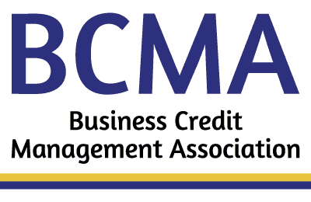 **WISCONSIN CREDIT ASSOCIATION, INC**

**WCA COMMERCIAL COLLECTION** **PLACEMENT FORM**

***ATTN CREDITOR:*** PLEASE COMPLETE THIS PLACEMENT FORM AND ATTACH COPIES OF ALL AVAILABLE DOCUMENTS:

Signed Credit Application, including Terms and Conditions, Corporate or Personal Guaranty, current or most recent itemized Account Statement, copies of all open Invoices and Credits, Credit Reports, signed Purchase or Work Orders, original NSF checks, and any pertinent correspondence to or from Debtor in support of this debt as well as your comments about this claim.

You will receive a letter confirming receipt of this claim.

***\*\*\*\* THERE SHOULD BE NO COMMUNICATION WITH DEBTOR ONCE CLAIM HAS BEEN PLACED WITH WCA \*\*\*\****

**\* Required Fields (If not complete, cannot be processed)**

**Your Information (CREDITOR)**

**\* Company Name: Click here to enter text.**

**\* Street or Mailing Address: Click here to enter text.**

**\* City, State, Zip: Click here to enter text.**

* **Company Phone: Click here to enter text. * Fax Number: Click here to enter text.**

**\* Contact Name & Position: Click here to enter text.**

**\* Contact Direct Phone/Extension: Click here to enter text. * Contact E-Mail: Click here to enter text.**

**BCMA Member Number** (Optional)**:**  **Click here to enter text.**

**Subject Information (DEBTOR)**

**\* Company Name: Click here to enter text.**

**\* Street or Mailing Address: Click here to enter text.**

**\* City, State, Zip: Click here to enter text.**

* **Company Phone: Click here to enter text. *Fax Number: Click here to enter text.**

**\* Company Principal: Click here to enter text.**

**\* Contact Name & Position: Click here to enter text.**

**\* Contact Direct Phone/Extension: Click here to enter text. *Contact E-Mail: Click here to enter text.**

**\* Contact Secondary Phone: Click here to enter text.**

**\* Is Debtor Still in Business:**  ☐ Yes ☐ No **\*Do you have a signed Personal Guaranty:** ☐ Yes ☐ No

**\*Amount of Claim: $ Click here to enter text.**

**I hereby authorize Wisconsin Credit Association to begin  Immediate OR  Free Demand (*\*\*Association Members ONLY**)* collection of this claim. For Free Demand Claims, send WCA Notice to Debtor and attach a copy of the Notice to this form. Members, send us your request for the Notice to Debtor form.**

**Authorized Company Representative & Title: __________________________________________________ Date _____________**

|  |
| --- |
| **Please send this form, with all available supporting documentation to:**  **WCA Commercial Recovery Services**  **PO Box 510157, New Berlin WI 53151-0157**  **E-Mail: collection@wcacredit.org**  **Office: 262.827.2880** |

*Revised Jan 2019*